|  |  |  |
| --- | --- | --- |
| **Problem Chosen**  C | **2025**  **MCM/ICM**  **Summary Sheet** | **Team Control Number**  2508999 |

**Predicting Olympic Success:**

**Medal Counts, First-Time Medalists, and the Impact of Elite Coaching and Event Dynamics**

**Abstract**

This study explores the determinants of national Olympic medal performance and the emergence of first-time medalist countries using comprehensive datasets from all Summer Olympic Games. **Leveraging multivariate linear regression** and **weighted modeling** techniques, we predict gold and total medal counts for each country, incorporating uncertainty estimates and evaluating model performance through robust validation metrics. Our projections for the 2028 Los Angeles Summer Olympics include detailed prediction intervals, identifying countries poised for improvement and those likely to experience declines compared to the 2024 Games. Additionally, the model accounts for nations that have yet to secure Olympic medals, providing **probabilistic forecasts** on the number of countries expected to achieve their first podium finishes in 2028, along with associated confidence levels. The relationship between the number and types of Olympic events and national medal outcomes is examined, highlighting key sports that significantly influence medal prospects for various countries and the impact of host nation event selections on performance. Furthermore, we investigate the "great coach" effect by employing **Difference-in-Differences (DID) analysis** and case studies of renowned coaches who have led multiple national teams to Olympic success. This analysis quantifies the contribution of exceptional coaching to medal counts and identifies strategic investment areas for three selected countries to enhance their Olympic performance through elite coaching. The findings offer novel insights into the dynamics of Olympic medal distributions and provide actionable recommendations for national Olympic committees to optimize their strategies in athlete development, event participation, and coaching investment

**KeyWords:** **Olympic Medal Performance, 2028 Projections, Great Coach Effect, Strategic Recommendations**

**Contents**

1 Introduction 3

1.1 Background 3

1.2 Restatement of Problems 3

1.3 Overview of Our Work 5

2 Data Analysis 6

3 Model Establishment and Solutions 8

3.1 Forecast 2028 Los Angeles Olympic Games 8

3.1.1 Data preparation and cleaning 8

3.1.2 Model Establishment 9

3.1.3 Analysis and Evaluation of results 10

3.2 First Olympic Medal Prediction Model 14

3.2.1 Model Development and Feature Engineering 15

3.2.2 Model Training and Validation 16

3.2.3 2028 Olympic Games First Medal Prediction 17

3.2.4 Conclusion 18

3.3 Event Selection and Hosting Choices 20

3.4 Investigating Factors Influencing Medal Counts: The "Great Coach Effect" 23

3.4.1 Difference-in-Differences Analysis of Performance Breakthroughs 23

3.4.2 Case Study Evidence: Lang Ping, Béla Károlyi, and Bob Bowman 25

3.4.3 Coach Replacement Priority Analysis and Recommendations 27

4 Conclusion 29

4.1 Insights for National Olympic Strategies 30

4.2 Broader Factors Influencing Olympic Success 30

4.3 Future Work 30

5 Reference 31

# 1 Introduction

## 1.1 Background

The Olympic Games have evolved dramatically from their ancient origins, when participation was limited to Greek-speaking athletes [1] . Today, they stand as the world's premier international sporting event, symbolized by the iconic five interlocking rings designed by Baron Pierre de Coubertin, the founder of the modern Olympics z . These rings, reprzesenting the five continents, perfectly embody the Games' inclusive spirit and global reach.

Since their modern revival in 1896, the Olympics have maintained a quadrennial schedule, with events spanning no more than 18 days. Throughout their modern history, the Games have demonstrated remarkable resilience, having been interrupted only during the two World Wars (cancelling the 1916, 1940, and 1944 events) and experiencing a single postponement in 2020 due to the global pandemic.

Beyond their sporting significance, the Olympics serve as a powerful catalyst for urban transformation and economic development in host cities [2]. This legacy extends far beyond the competition itself, often resulting in improved infrastructure, increased tourism, and lasting socioeconomic benefits for the host nation [3].

The 2024 Paris Olympics will showcase 329 gold medal events across 32 sports [4], with each precious medal containing six grams of pure gold and weighing 524 grams in total [5]. As the Games approach, global attention has increasingly focused on the medal count predictions, with media outlets and sports analysts from various countries already speculating about their nations' potential performance. This phenomenon reflects how Olympic medals have become not just symbols of athletic excellence, but also a measure of national pride and sporting prowess on the world stage.

## 1.2 Restatement of Problems

The aim of this study is to develop advanced, data-driven predictive models to accurately forecast medal standings for the 2028 Los Angeles Summer Olympic Games. Utilizing historical data on past medal counts, host nations, and event distributions, the study seeks to address the following critical challenges:

**1. Medal Count Prediction:**

Construct predictive models for forecasting the number of gold medals and overall medal counts for each National Olympic Committee (NOC) participating in the 2028 Games. The models will incorporate uncertainty estimates and evaluate their predictive accuracy using robust performance metrics, such as Mean Squared Error (MSE), Mean Absolute Error (MAE), and the coefficient of determination (R²). These metrics will ensure rigorous validation of the models' reliability and precision.

1. **Medal Ranking Forecasting:**

Based on the predictive outputs, estimate the final medal rankings for each country in the 2028 Olympics, including prediction intervals to account for uncertainty. Additionally, identify nations likely to exhibit notable improvements or declines in their rankings relative to their performance in the 2024 Paris Summer Olympics, offering a nuanced understanding of potential shifts in global competitiveness.

1. **First-Time Medalists Analysis:**

Extend the predictive framework to include countries that have yet to win an Olympic medal. Forecast the number of nations likely to secure their first-ever medal at the 2028 Games and estimate the probabilities associated with these groundbreaking achievements. This analysis will provide insights into the broader inclusivity of the Olympic movement.

1. **Event-Specific Dynamics:**

Analyze the relationship between the number and types of Olympic events and the medal performance of competing nations. Identify the most critical sports that contribute to the success of different countries and assess the influence of event selection by the host nation on overall medal outcomes. This aspect will shed light on strategic prioritization for both host and non-host countries.

1. **Impact of Coaching Transitions (“Coach Effect”):**

Investigate the potential influence of high-profile coaches switching national teams on medal performance. Quantify the contribution of this “coach effect” and recommend specific sports and countries where employing elite coaches could substantially enhance medal prospects. This analysis will provide actionable guidance for leveraging coaching expertise to maximize competitive advantage.

## 1.3 Overview of Our Work

In this study, we present a robust analytical framework for predicting Olympic medal counts and identifying potential first-time medalist nations for the 2028 Los Angeles Summer Olympics. Our approach is structured as follows:

**Data Cleaning and Integration:** We initiated our analysis by meticulously cleaning and preprocessing the provided datasets. This involved merging multiple data sources, including medal tables, host country information, Olympic event details, and individual athlete performances. To ensure the reliability of our models, we restricted our analysis to data from the year 2000 onwards, thereby focusing on recent trends and minimizing the impact of historical anomalies.

**Feature Engineering:** We counted the total number of gold, silver, bronze and total MEDALS won by each country since 2000

#### Medal Count Prediction:

**Country Classification:** We categorized countries based on their Olympic participation history. Countries that have never missed the Olympics were modeled using multivariate linear regression to predict their medal counts. For nations that have previously missed the Games, we applied weighted models to account for the variability in their participation. Additionally, countries that have participated only once were subjected to direct prediction methods due to their limited historical data.

**First-Time Medalist Prediction:** Addressing the novel aspect of identifying countries poised to win their first Olympic medals, we implemented classification algorithms, including Random Forest classifiers calibrated with Synthetic Minority Over-sampling Technique (SMOTE) to handle class imbalance. These models predict the probability of each country achieving its inaugural medal, accompanied by confidence intervals to assess the precision of these predictions.

#### Impact of Great Coaches:

**Difference-in-Differences (DID) Analysis:** To explore the "great coach" effect, we employed Difference-in-Differences (DID) analysis, enabling us to quantify the contribution of elite coaching to national medal counts. This method allowed us to isolate the impact of coaching changes from other confounding factors affecting Olympic performance.

**Conclusion and Future Work:** We conclude by summarizing the key findings of our study, discussing their implications for national Olympic strategies, and highlighting the broader factors influencing Olympic success. We also outline potential avenues for future research, including the integration of more granular athlete performance metrics and the exploration of socio-economic factors affecting Olympic outcomes.

# 2 Data Analysis

An analysis of Olympic excellence across nearly two and a half decades reveals fascinating patterns in the distribution of medals among leading sporting nations. The dataset, spanning from 2000 to 2024, offers a compelling narrative of international athletic achievement and national sporting prowess, illuminating the intricate dynamics of global sporting competition.

The perennial fascination with Olympic powerhouses draws our attention to an elite circle of nations that have consistently dominated the medal tables. Through meticulous analysis of historical data, we can identify these Olympic titans who have maintained their reign at the pinnacle of sporting excellence. These perennial champions, led by the United States and followed closely by sporting giants like China and UK, have established themselves as the true emperors of the Olympic arena, consistently commanding the upper echelons of the medal standings with remarkable persistence.

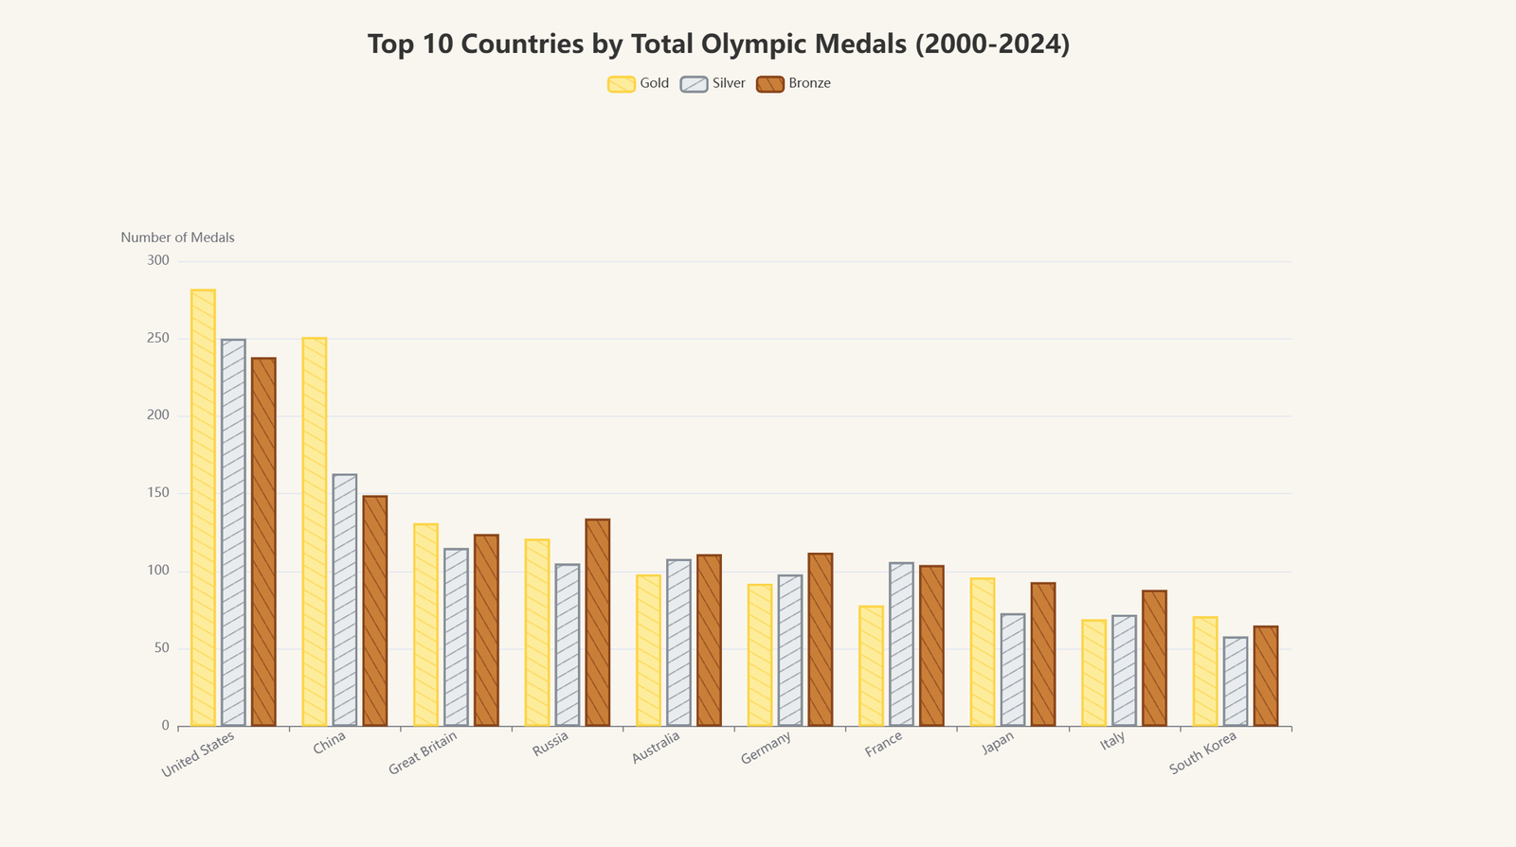

2-1 Top 10 Contries

A closer examination of the United States' performance reveals a remarkably balanced medal distribution, with consistently high gold medal counts year after year and an impressively proportional distribution across gold, silver, and bronze. This stands in stark contrast to their closest competitor, China, whose singular focus on gold medals reflects a controversial approach to Olympic success. The Chinese strategy, which often diminishes the achievements of non-gold medalists, appears to be driven by a nationalistic desire to surpass the US gold medal count, feeding into a carefully cultivated narrative of national superiority. Yet, despite this intense focus on gold medals and the immense pressure placed on their athletes, they consistently fall short of overtaking the United States' overall Olympic dominance.

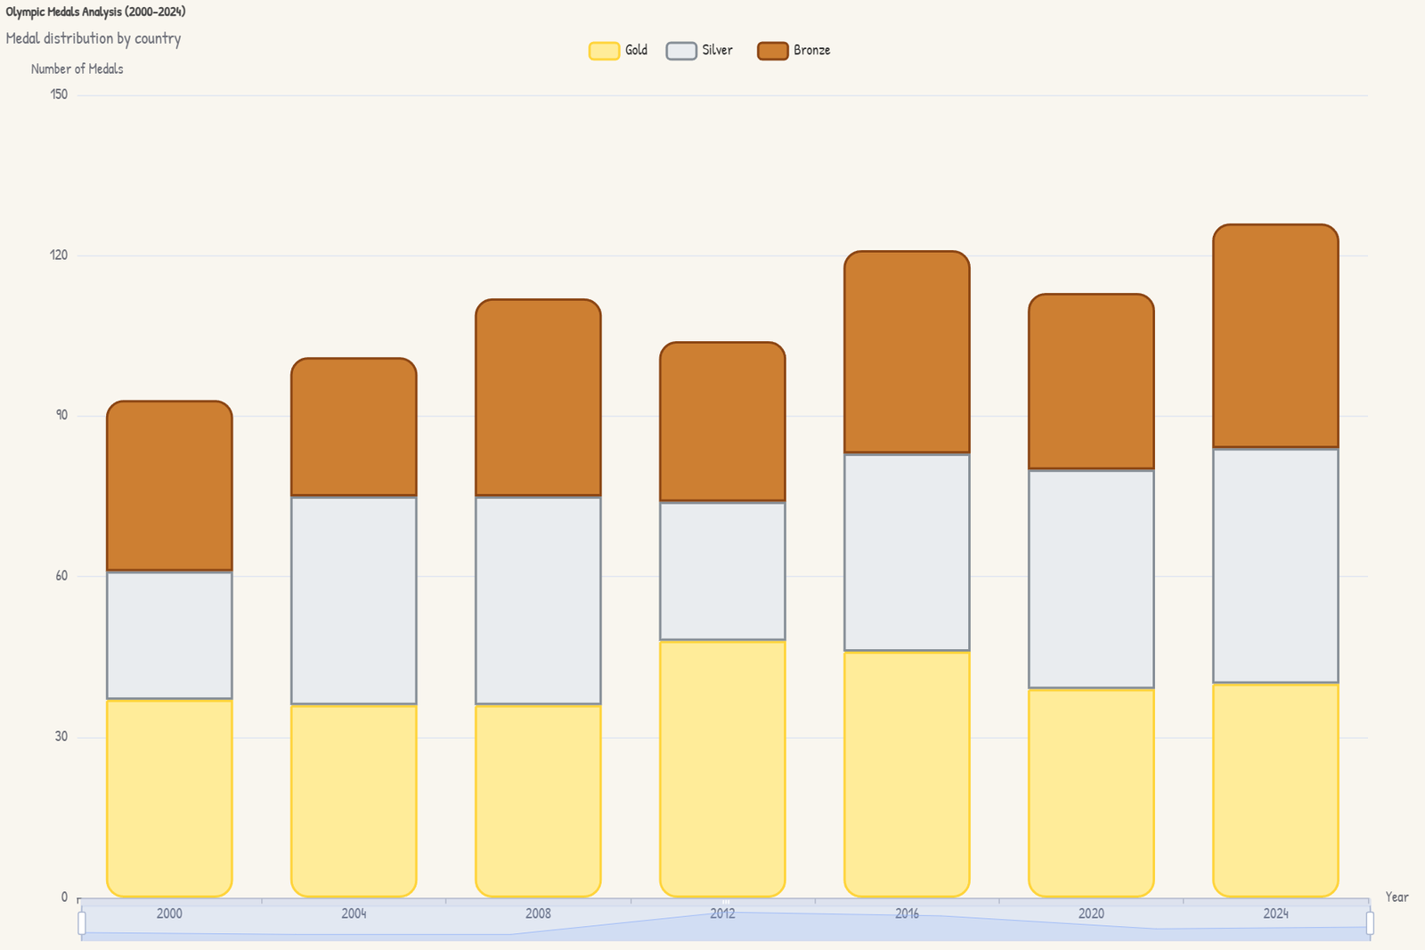

2-2 US Medal Distribution

Within our comprehensive analysis, we've uncovered a fascinating phenomenon of medal consistency among certain nations. While some countries maintain their stable positions through sheer sporting supremacy and robust athletic infrastructure, others display an intriguing pattern of consistency that defies conventional expectations. This remarkable stability in medal acquisition, whether at the top tier or in more modest positions, presents an engaging paradox in Olympic performance patterns, warranting deeper investigation into the underlying factors that contribute to such sustained achievement levels.

**2-3 Olympic Ranking Stability Analysis (2000-2024)**

Countries sorted by standard deviation, darker color indicates higher ranking

# 3 Model Establishment and Solutions

## 3.1 Forecast 2028 Los Angeles Olympic Games

In this section, we will detail the process of building the time series model used to predict the number of MEDALS in each sport for each country at the 2028 Los Angeles Olympic Games. Wunderlich and Memmert (2021) highlighted the importance of machine learning in forecasting Olympic outcomes.D[6] The purpose of the model is to predict the medal performance of each sport in the future Olympic Games through the analysis of historical data, so as to assist decision-making and strategic planning.

### 3.1.1 Data preparation and cleaning

We used the data in "summerOly_athletes.csv" and "" in this process, considering the time cycle of the Olympic Games, many athletes retired after participating in the two Olympic Games. In addition, the performance level of each country in the Olympic Games is related to the comprehensive national strength of the country. In addition, the competition system of the pre-2000 Olympic Games is also quite different from the present, so we discard all the data before 2000 and only intercept the data after 2000 for use.

Because of the different events of each Olympic Games, the different events will have a huge impact on the medal. It is very important to ensure that the events we predict are present at the 2028 Olympic Games. We used the latest available 2028 Los Angeles Games sports list (available on the official website) as a condition to exclude those sports that do not exist at the 2028 Games.

In order to make better use of our time series model, we extend it with existing data. We created the historical medal count, starting from 2000, adding up gold, silver, bronze, and total medal count as our complementary feature. At the same time, to simplify the model, we combine the same rows for Sport, and de-duplicate the gold medal statistics for team events (because in the athlete table, a team event will award a gold medal to each person, but this should only be counted once when calculating the national gold medal count).

To categorize events as team-based, we first compiled a list of sports inherently involving teams, such as Basketball, Football, and Volleyball. Additionally, we identified specific keywords commonly associated with team events, including "Team," "Doubles," "Pair," "Mixed," "Four," and "Eight." By examining each event’s sport and its name, we classified an event as a team event if it belonged to the predefined team sports or contained any of the team-related keywords. This combined approach ensures a comprehensive and accurate identification of team events, facilitating more precise analysis and modeling in our study.

As there is no overall information yet on the countries participating in the 2028 Olympics, we can only extrapolate using what we know[7]. We excluded countries whose last Olympic participation was less than 2012. Because these countries are not likely to participate in the 2028 Olympic Games, and there is a lack of reference data, we will not consider these countries

### 3.1.2 Model Establishment

For countries that are not absent, we use a multiple linear regression model to make predictions.

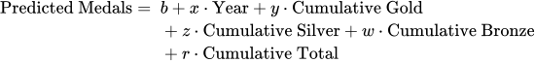

|  |  |
| --- | --- |
| **Variable** | **Description** |
| Year | The year of the competition |
| Cumulative Gold | Historical cumulative gold medals |
| Cumulative Silver | Historical cumulative silver medals |
| Cumulative Bronze | Historical cumulative bronze medals |
| Cumulative Total | Historical cumulative total medals |

table 3-1 variable description

For countries that have participated only once or won the same number of MEDALS each time, we do not use the model to complicate the process, but directly use the number of MEDALS last participated as the result of the prediction

For countries with absences in the middle, we use post-2012 data to make predictions (if the last participation was taken out before 2012), and the specific formula is as follows

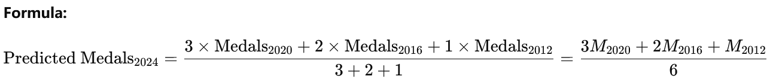



descript

For countries with gaps in participation, the weighted average is calculated based on available data, adjusting weights as necessary

### 3.1.3 Analysis and Evaluation of results

#### 3.1.3.1 Country forecasts are not absent

We sampled two representative countries (China and the United States) to demonstrate the predictive performance of our model.

The predictive performance of the ARIMA model is evaluated by the residual analysis diagram and the comparison between the predicted and the actual values.

The residual analysis diagram shows that most of the residual errors are concentrated in the range of ±2, indicating that the prediction error of the model is small and evenly distributed, indicating that the model has a good fitting effect on the whole.

The comparison between the predicted and the actual values further verifies the validity of the model. The actual number of MEDALS in most sports is highly consistent with the predicted value, reflecting the high accuracy of the model in these sports. However, for a small number of sports, the deviation may be due to large data fluctuations or the model does not adequately capture their specific trends. This suggests that in future model optimization, we need to conduct more in-depth analysis and adjustment for these underperforming projects.

By combining these two charts, we confirm that the ARIMA model is stable and reliable in predicting most sports, while identifying specific areas that need improvement to improve the overall accuracy of the forecast.

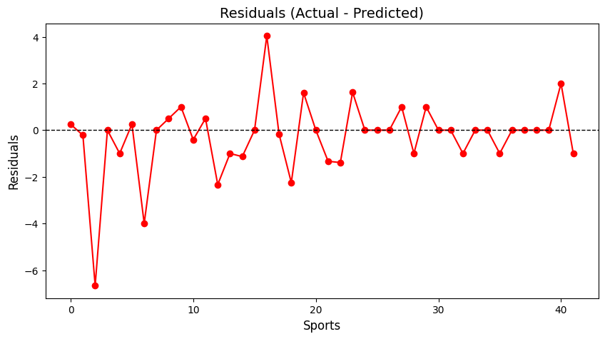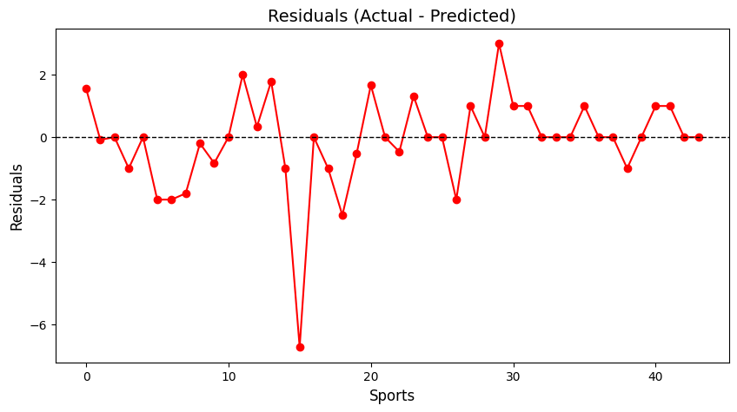

3-1 Residual visualization (left China, right USA)

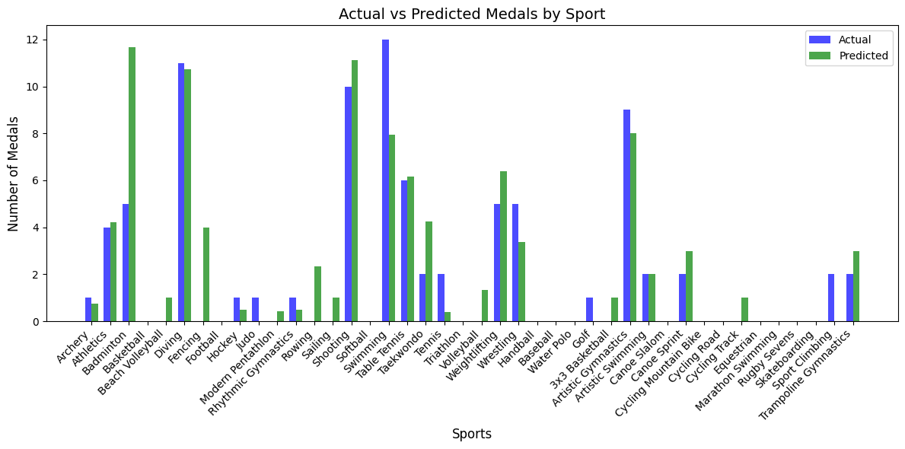

3-2 China Actual vs Predicted Medals Plot

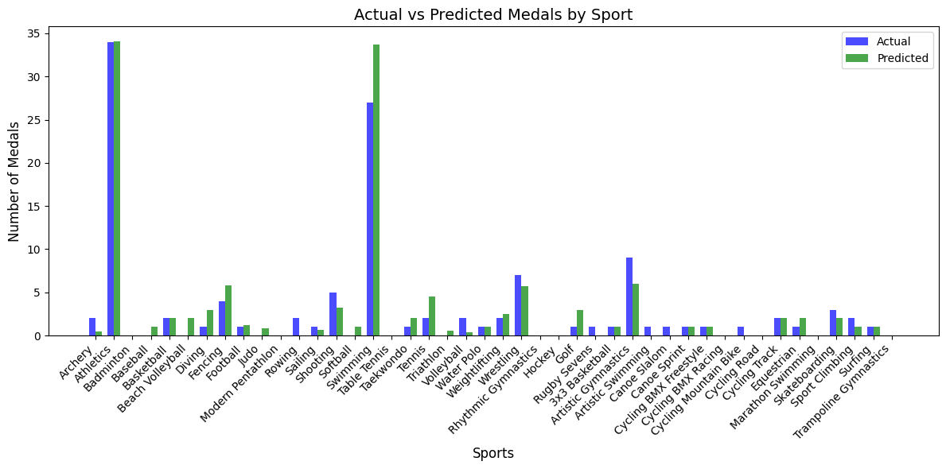

3-3 USA Actual vs Predicted Medals Plot

We also counted the MSE and MAE of the predicted results, as shown in the table below

|  |  |  |
| --- | --- | --- |
|  | **MSE** | **MAE** |
| **CHN** | 2.65 | 0.94 |
| **USA** | 2.75 | 0.94 |

table 3-2 MSE & MAE of China & USA

#### descript3.1.3.2 Projections for countries that have participated only once

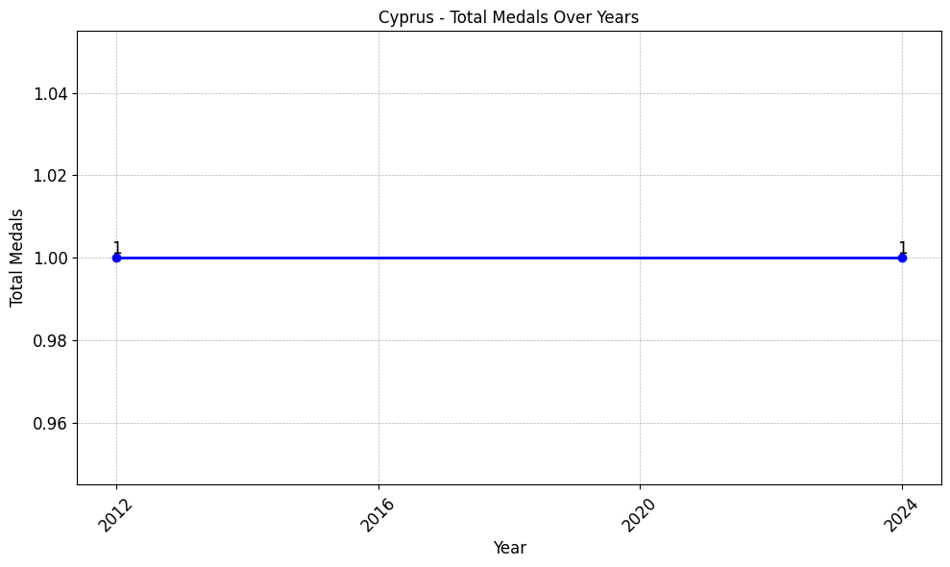

3-4 Bermuda & Cypurs Total Medals (left-Bermuda, right-Cypurs)

For countries that have only participated in one Olympics or that have a fixed number of MEDALS per event, such as Bermuda and Cyprus, we keep their MEDALS numbers and do not process or predict them too much.

#### 3.1.1.3 For countries absent from participation

We tried some models like Xgboost, ARIMA, but they didn't work well. Analyzing the reasons, we believe that the Olympic Games has a very important time factor. Every four years, the quality of the contestants changes significantly, and the use of overly complex models without the use of external data increases entropy. So, for the countries here, we use something like a weight-based calculation.

We use Australia as an example here. From the residual analysis chart and the actual bar chart, we can see that the prediction ability of this method is good for most motions. We also calculated the MSE and MAE of the predicted results, which were 1.43 and 0.62, respectively.

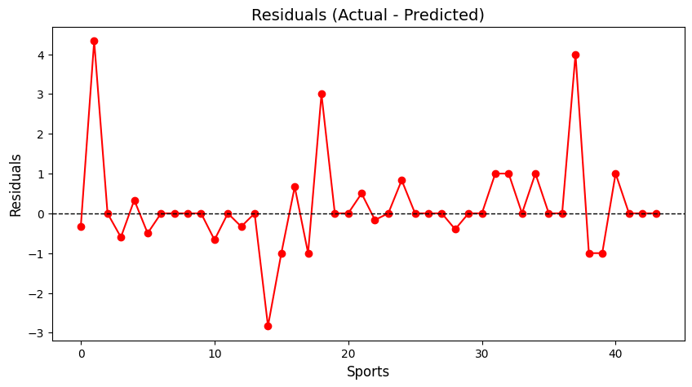

3-5 Australia Residual visualization

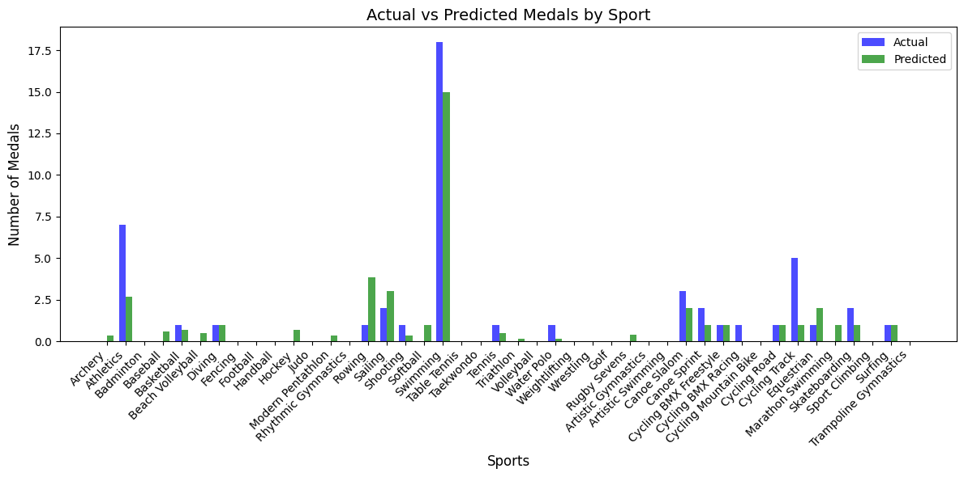

3-6 Australia Actual vs Predicted Medals Plot

#### 3.1.1.4 Results

|  |  |  |  |
| --- | --- | --- | --- |
| **NOC** | **Predicted Medal** | **NOC** | **Predicted Medal** |
| USA | 69 | ITA | 12 |
| CHN | 65 | KEN | 12 |
| GBR | 28 | CAN | 12 |
| KOR | 23 | FRA | 10 |
| GER | 15 | UKR | 10 |

table 3-2 Top10 Priedicted Medal

|  |  |  |  |
| --- | --- | --- | --- |
| **NOC** | **Predicted Gold** | **NOC** | **Pridicted Gold** |
| CHN | 43 | JAM | 8 |
| USA | 30 | KEN | 7 |
| KOR | 17 | NED | 7 |
| GBR | 15 | CAN | 6 |
| GER | 11 | ITA | 6 |

table 3-3 Top10 Priedicted Gold

|  |  |  |  |
| --- | --- | --- | --- |
| **NOC** | **Predicted Silver** | **NOC** | **Predicted Silver** |
| USA | 39 | KOR | 7 |
| CHN | 22 | ITA | 6 |
| GBR | 13 | ESP | 6 |
| IRI | 8 | CUB | 6 |
| JPN | 7 | CAN | 5 |

table 3-4 Top10 Predicted Silver

## 3.2 First Olympic Medal Prediction Model

A key objective is to predict nations likely to win their first Olympic medals, promoting inclusivity in the Olympic movement. Unlike typical medal forecasts, this model targets countries aiming to surpass the 'zero-medal' mark, significant for global Olympic universality.

### 3.2.1 Model Development and Feature Engineering

We developed a binary classification model to predict a country's first Olympic medal win in a given year (Yes/No), using only internal organizing committee datasets, adhering to competition rules.

Data constraints included raw data across tables with format inconsistencies and varied country name representations. Standardizing country names was crucial for integrating summerOly_athletes.csv, summerOly_medal_counts.csv, and summerOly_hosts.csv.

**Key data integration and feature extraction steps included:**

NOC Full Name and Abbreviation Unification: Creating a country full name to NOC abbreviation mapping from summerOly_athletes.csv to link tables. Country names in the ‘Team’ column were cleaned to ensure consistency with NOC codes.

Host Country Information Extraction: Parsing the "City, Country" format in summerOly_hosts.csv ‘Host’ column to extract and link host country information. Fuzzy string matching addressed name variations, using a similarity threshold (80%) to match names to the athlete dataset's ‘Team’ column when direct matches failed.

**Feature Engineering: Engineered features include:**

a. Athlete Participation Features: Total athletes, male/female athlete ratio, sport/discipline diversity, athletes per event, Olympics participated, years since first participation. These reflect Olympic engagement scope.

b. Host Country Features: Host history count, years since last hosting, current host status, potentially influencing medal outcomes.

c. Historical Medal Features: Medals from recent Olympics, averages over recent Games, and historical totals (under hypothetical prior wins – zero for countries never medaled in training). These indicate Olympic strength and trends.

### 3.2.2 Model Training and Validation

We used a Random Forest Classifier with TimeSeriesSplit cross-validation and SMOTE oversampling to manage class imbalance. Model performance was evaluated using F1-score, classification report, and confusion matrix. Feature importance was analyzed to identify key prediction drivers.

On the validation set (2020 & 2024 data), the model achieved an overall accuracy of 0.50. The F1-score for predicting first-time medal wins was 0.30, with precision at 0.25 and recall at 0.38 for this class. The confusion matrix showed that of 8 actual first-time medal winners, 3 were correctly identified, and of 20 non-first-time winning countries, 11 were correctly predicted. Feature importance analysis highlighted sport_diversity_count, athlete_count_total, athlete_count_male, and event_entry_count as most influential, suggesting broader sports representation and larger athlete contingents are key indicators. SHAP value analysis was technically limited.

### 3.2.3 2028 Olympic Games First Medal Prediction

The model predicted first-time medal probabilities for 77 countries without prior medals before 2024. Monte Carlo Simulation (5000 iterations) assessed prediction uncertainty.

Top predicted countries for first medals in 2028 include Guinea, Congo (Kinshasa), and Nepal. The Monte Carlo simulation median predicted approximately 28 first-time medal-winning countries, with a 95% confidence interval from about 26 to 30.

### 3.2.4 Interpretation and Analysis of Prediction Results

High probabilities for countries like Guinea, Congo (Kinshasa), and Nepal may reflect increasing athlete participation, even without past medals. Feature importance supports this, linking broader participation to first medal likelihood. The Monte Carlo simulation’s confidence interval (26-30) acknowledges prediction uncertainty.

Model limitations include reliance on internal data, potentially missing external factors influencing Olympic success. The validation F1-score (0.30) indicates limited predictive power for first-time winners specifically, with better performance in identifying non-first-time winners.

Despite limitations, predictions offer insights for national Olympic committees. High-probability countries might benefit from continued sports investment. Committees seeking first medals can strategically focus on diversifying sports and increasing athlete representation, aligning with model-identified key features.

## 3.3 Event Selection and Hosting Choices

Investigating How Event Selection and Hosting Choices Influence Medal Outcomes Across Nations in the Olympic Games

This study delves into the profound impact of event selection and hosting strategies on medal outcomes, focusing on case studies from the United States, Jamaica, and China. By examining trends across multiple Olympic Games, the research offers valuable insights into the dynamics of national medal success and the strategic decisions shaping these outcomes.

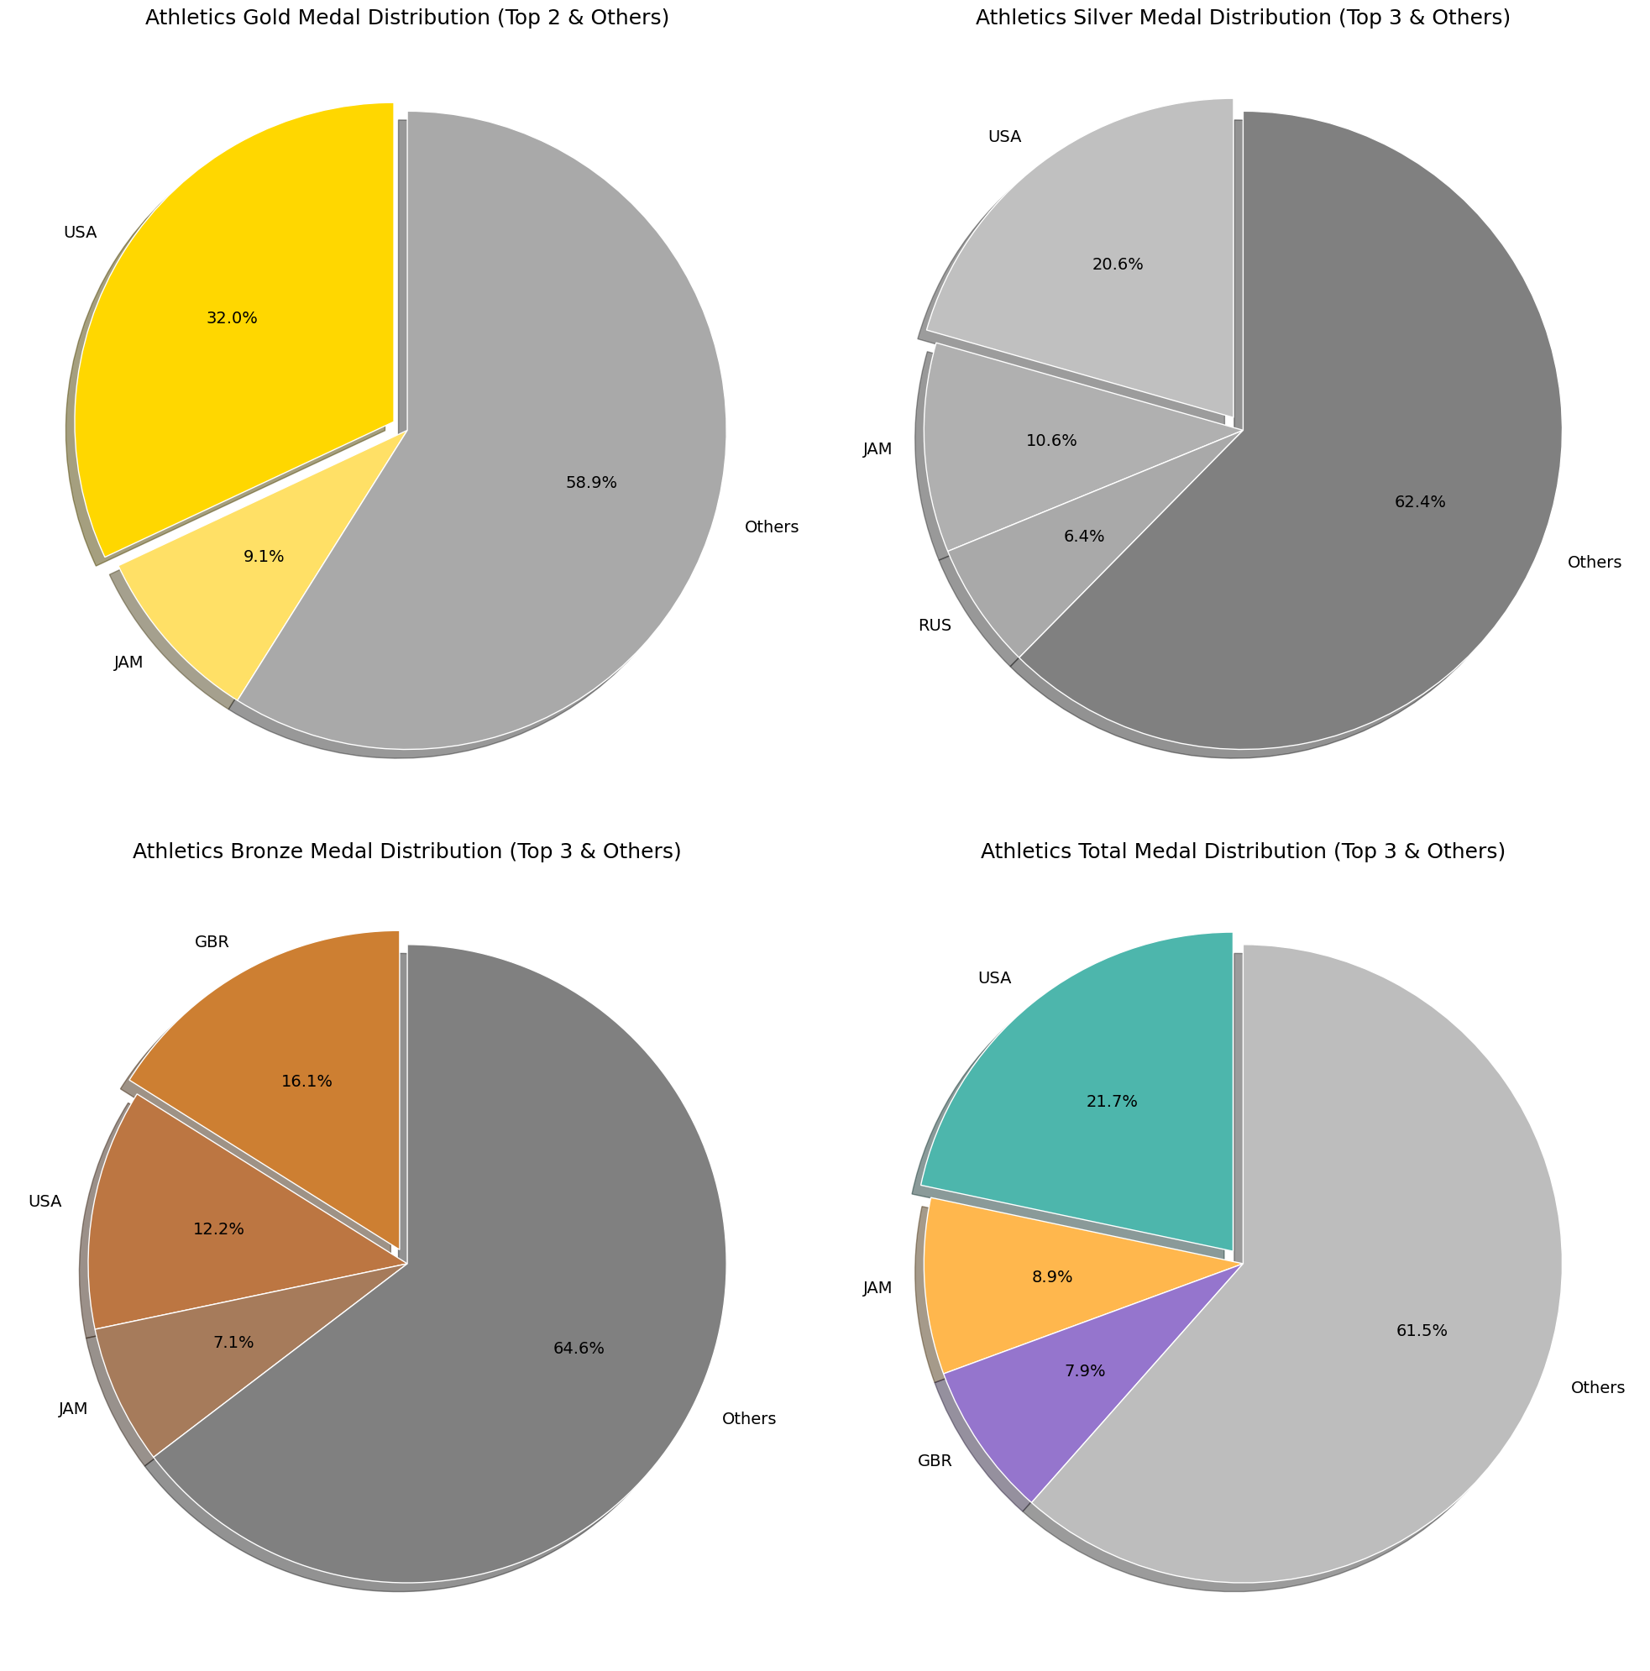

3-7 Gold, silver, and bronze MEDALS won by the USA in Athletics at the 2000-2024 Olympics

An analysis of medal counts in Athletics from the 2000 to 2024 Olympic Games demonstrates the United States' dominance in this discipline. Over this period, the U.S. secured 32% of all gold medals in Athletics, significantly outperforming Jamaica, which captured 9.1%, placing it in second. Furthermore, the United States accounted for 21.7% of the total medal tally, far exceeding Jamaica's 8.9%. These figures highlight the strategic significance of Athletics in the overall success of Team USA at the Olympic Games[8] (Si, 2018).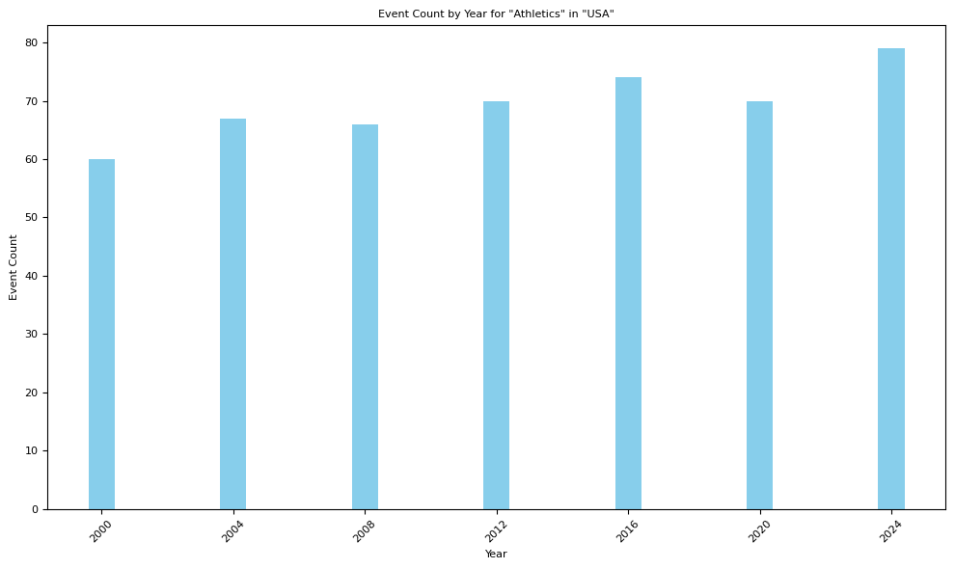

3-8 The events contained in Athletics at each Olympic Games from 2000 to 2024

The expansion of Athletics as a discipline at the Olympic Games is evident from 2000 to 2024, with the number of events increasing from 60 to nearly 80. This growth reflects heightened global interest and the sport's pivotal role in the Games. The United States has benefited considerably from this trend, with its medal count in Athletics increasing alongside the number of events, further cementing its dominance in the sport. This correlation aligns with previous findings that event selection significantly impacts medal success, particularly for dominant nations like the U.S.[9] (Si, 2018; Katz, 2024).

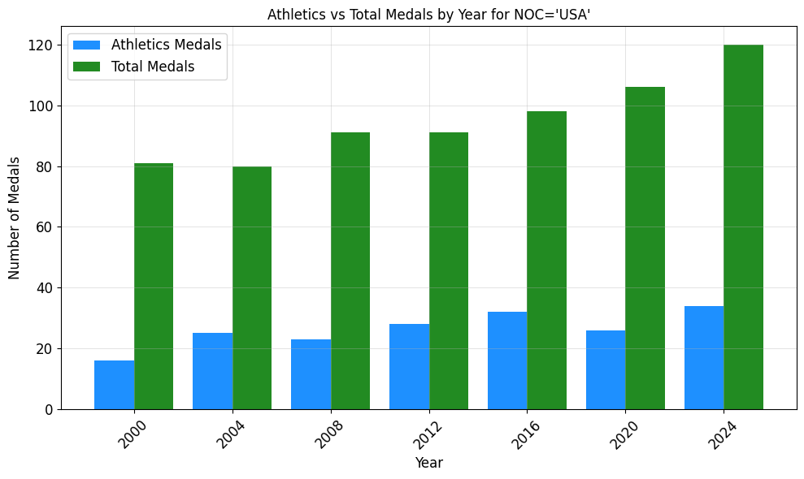

3-9 The total medals and medals in Athletics of USA from 2000 to 2024

Between 2000 and 2024, the United States' performance in Athletics saw a remarkable upward trajectory, with gold medal counts increasing from 15 to 35 and overall medal counts rising from 82 to 120. This trend underscores the vital role of Athletics in contributing to the overall success of Team USA. The analysis confirms that the increasing emphasis on this discipline has not only enhanced medal totals but also bolstered the country's standing in global rankings. Such results resonate with Katz’s (2024) argument that data-driven predictions and strategic event prioritization are integral to optimizing Olympic performance.

Applying a similar analytical lens to other nations, Jamaica's dominance in sprinting events emerges as a significant factor in its Olympic success. The nation’s medal tally in Athletics aligns almost perfectly with its performance in running disciplines, highlighting the disproportionate impact of sprint events on its overall medal outcomes. This finding is consistent with prior research attributing Jamaica's success to cultural and systemic factors that favor sprinting excellence (Taylor, 2015) [10].

In contrast, China’s supremacy in Diving reflects a focused investment in a single discipline to achieve maximum impact. Diving consistently accounts for a substantial proportion of China’s gold medal tally, showcasing the nation’s strategic resource allocation and elite coaching systems (Zheng, 2024)[11]. For instance, Zheng (2024) highlights how China’s success in Diving stems from both its technical expertise and a long-term commitment to nurturing talent in this highly specialized field.

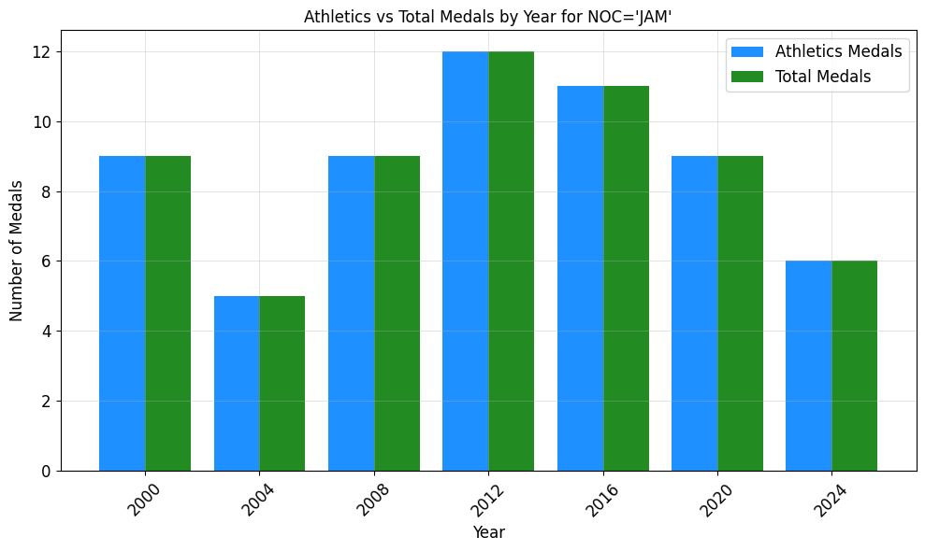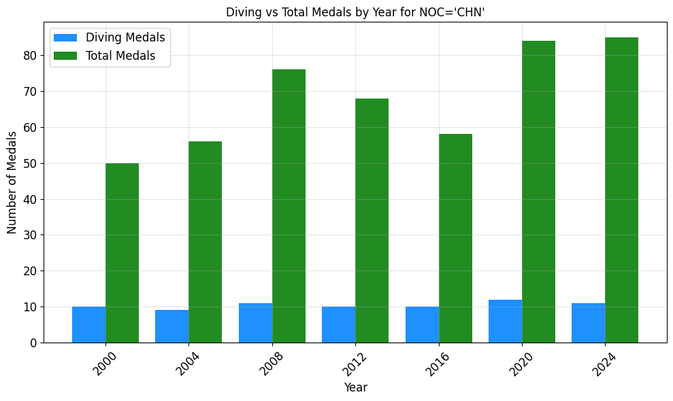3-10 The Total medals from JAM & CHN (left-JAM right-CHN)

## 3.4 Investigating Factors Influencing Medal Counts: The "Great Coach Effect"

### 3.4.1 Difference-in-Differences Analysis of Performance Breakthroughs

To assess the general impact of performance enhancements potentially linked to coaching or program changes, we utilized a difference-in-differences (DID) model. This model examines the effect of a "treatment" condition, defined by either a significant performance breakthrough (exceeding a weighted medal score threshold) or a high influx of new athletes, on weighted medal scores.

The DID model specification is:

**descript**

where Weighted_Score represents the weighted medal score, Treat is a binary treatment indicator, β0 is the intercept, β1 is the treatment effect coefficient, and ε is the error term. Pooled OLS with clustered standard errors was used for estimation.

The results of the DID model reveal a statistically significant and positive coefficient for the Treat variable (β1 = 0.7904, p < 0.0001). This suggests a positive association between the defined "treatment" conditions and increased weighted medal scores. Figure 1 visualizes the trend comparison between treated and control groups, while Figure 2 presents the coefficient estimates.

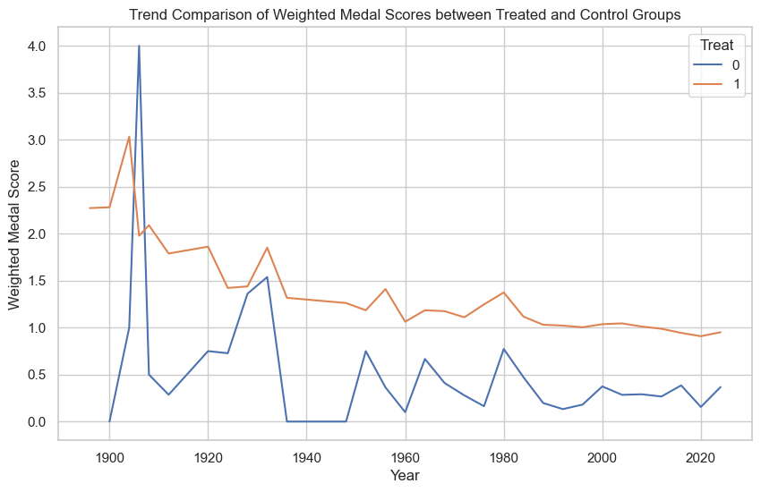

Trend Comparison of Weighted Medal Scores between Treated and Control Groups .

The blue line represents the average weighted medal score trend for the control group (Treat=0), while the orange line represents the trend for the treated group (Treat=1).

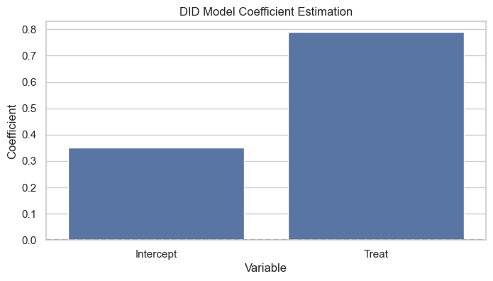 DID Model Coefficient Estimation.

This bar chart displays the estimated coefficients for the Intercept and Treat variables from the DID model. Error bars (if applicable) would represent confidence intervals for the coefficient estimates.

The positive and significant coefficient in the DID model suggests that factors captured by our "treatment" definition, potentially including effective coaching interventions, are associated with improved medal performance. However, to explore the "great coach effect" more directly, we now turn to case studies of specific renowned coaches.

### 3.4.2 Case Study Evidence: Lang Ping, Béla Károlyi, and Bob Bowman

To delve deeper into the potential "great coach effect," we conducted case studies focusing on three prominent coaches: Lang Ping (Volleyball), Béla Károlyi (Gymnastics), and Bob Bowman (Swimming). These coaches are widely recognized for their exceptional achievements and influence within their respective sports.

#### Lang Ping and Chinese Women's Volleyball

The analysis of Lang Ping's coaching tenures with the Chinese women's volleyball team reveals a compelling positive impact. As shown in Figure 3, weighted medal scores and performance breakthrough probabilities were significantly higher during her coaching periods compared to non-coaching periods.

**Figure 3:** Lang Ping Coaching Period Impact on Chinese Women's Volleyball.

(a) Box plot comparing weighted medal score distributions.

(b) Bar chart comparing performance breakthrough probabilities.

(c) Box plot comparing new athlete ratio distributions.

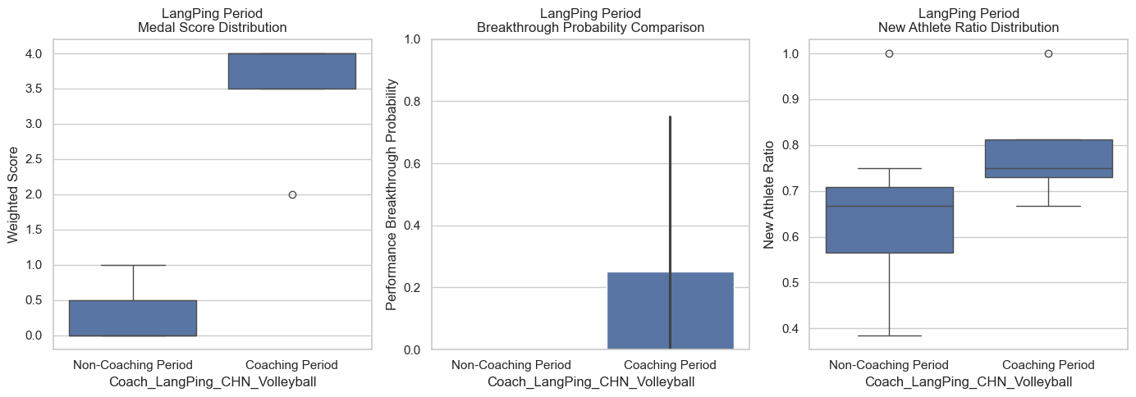

The data strongly suggests that Lang Ping's coaching expertise contributed significantly to the medal success of the Chinese women's volleyball program, providing strong evidence for the "great coach effect" in this specific context.

#### Béla Károlyi and US Women's Gymnastics

The case of Béla Károlyi and US women's gymnastics, presented in Figure 4, offers a more nuanced perspective. While a slight increase in average weighted medal score is observed during his coaching-associated years, the performance breakthrough rate is lower.

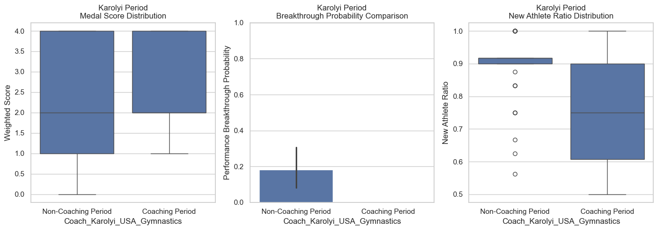**Figure 4:** Béla Károlyi Coaching Period Impact on US Women's Gymnastics.

(a) Box plot of weighted medal score distributions.

(b) Bar chart of performance breakthrough probabilities.

(c) Box plot of new athlete ratio distributions.

This suggests that Károlyi's influence may be characterized by sustained high performance and athlete development rather than solely breakthrough events, indicating a different manifestation of potential coaching impact.

#### Bob Bowman and US Swimming

Figure 5 presents the analysis for Bob Bowman and US swimming. Contrary to expectations, weighted medal scores and breakthrough probabilities are slightly lower during his coaching years.

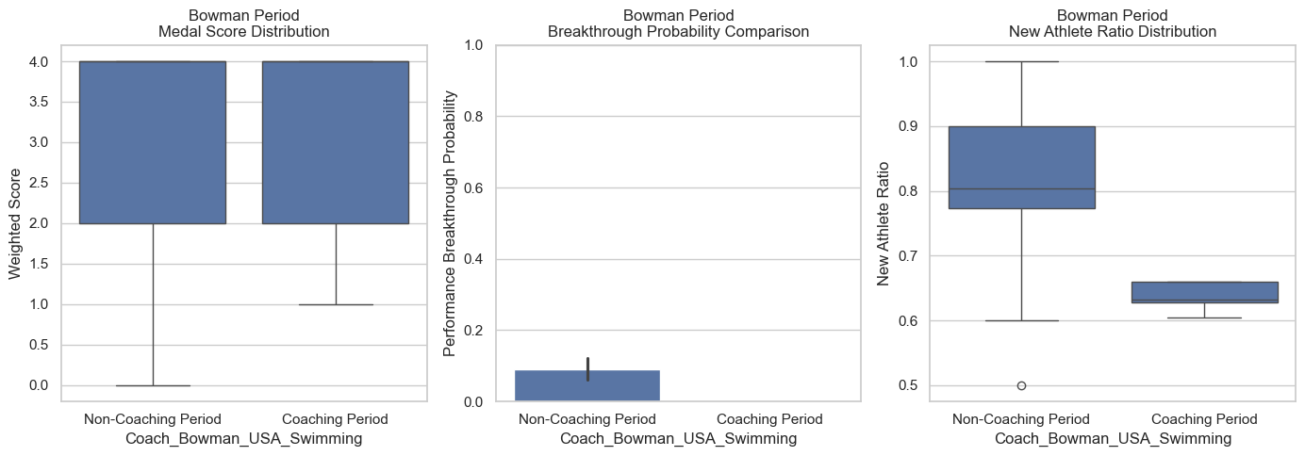**Figure 5:** Bob Bowman Coaching Period Impact on US Swimming.

(a) Box plot of weighted medal score distributions.

(b) Bar chart of performance breakthrough probabilities.

(c) Box plot of new athlete ratio distributions.

Several factors could explain this:

* **Ceiling Effect:** US swimming was already a dominant force before Bowman's tenure. Further significant increases in weighted medal scores might be inherently difficult to achieve due to a performance ceiling.
* **Focus on Individual Excellence:** Bowman's impact might be highly concentrated on individual athletes like Michael Phelps. Our analysis, aggregated at the national team level, might not fully capture the nuances of his individual athlete development expertise.
* **Broader Systemic Factors:** US swimming's overall success is likely influenced by a complex system of athlete development, funding, and infrastructure, beyond the influence of a single coach, even one as prominent as Bowman.

### 3.4.3 Coach Replacement Priority Analysis and Recommendations

To provide actionable recommendations for Olympic committees, we conducted a coach replacement priority analysis to identify country-sport combinations where investing in a "great coach" might be most impactful. This analysis ranks combinations based on a "Priority Score" calculated from factors indicating declining performance and athlete turnover. The Priority Score is derived from:

* **Score_Trend (Weighted Medal Score Trend):** Negative trend indicates declining performance, increasing priority.
* **New_Ratio_mean (Average New Athlete Ratio):** Lower new athlete ratio (higher athlete retention/staleness) increases priority.
* **Score_MA3_last (Last 3-year Moving Average of Weighted Score):** Lower recent performance increases priority.

|  |  |  |  |  |  |  |
| --- | --- | --- | --- | --- | --- | --- |
| **Rank** | **NOC** | **Sport** | **Event** | **Priority Score** | **Score Trend** | **New Ratio mean** |
| 1 | SLO | Rowing | Rowing Men's Double Sculls | 0.724 | 0.75 | 0.685 |
| 2 | ITA | Modern Pentathlon | Modern Pentathlon Men's Team | 0.672 | 0.75 | 0.556 |
| 3 | BRA | Sailing | Sailing Men's Two Person Keelboat | 0.671 | 0.75 | 0.552 |

table 3-1 Top 3 Country-Sport-Event Combinations for Coach Replacement

Figures 7, 8, and 9 further illustrate the recent performance trends for these top three combinations, showing the decline in Weighted_Score and New_Ratio over the past three Olympic cycles.

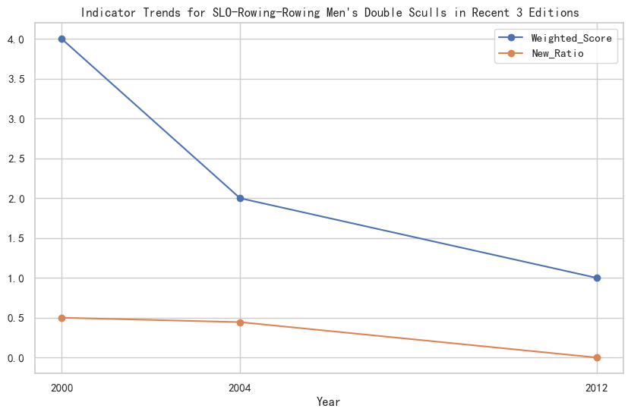**Figure 7:** Recent Performance Trends for BRA-Sailing-Sailing Men's Two Person Keelboat. Line chart showing Weighted_Score and New_Ratio trends over the last three Olympic cycles.

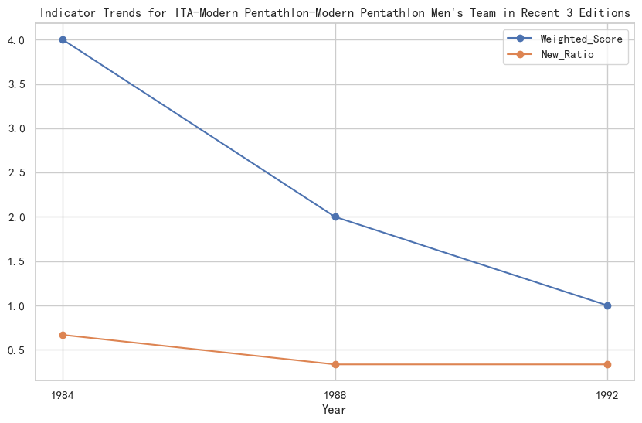**Figure 8:** Recent Performance Trends for SLO-Rowing-Rowing Men's Double Sculls. Line chart showing Weighted_Score and New_Ratio trends over the last three Olympic cycles.

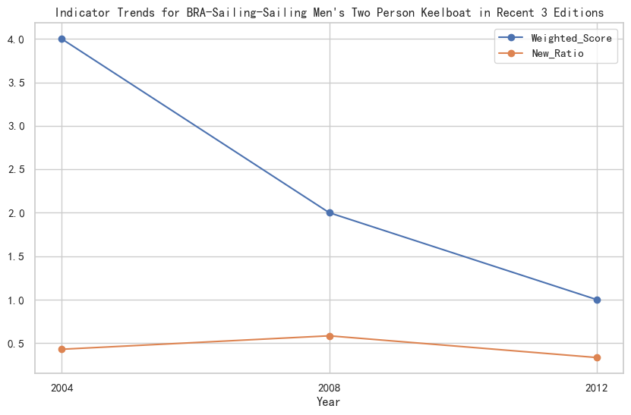**Figure 9:** Recent Performance Trends for ITA-Modern Pentathlon-Modern Pentathlon Men's Team. Line chart showing Weighted_Score and New_Ratio trends over the last three Olympic cycles.

Based on this analysis, we recommend that the Olympic committees of **Slovenia (SLO), Italy (ITA), and Brazil (BRA) should consider investing in "great coaches" for Rowing Men's Double Sculls, Modern Pentathlon Men's Team, and Sailing Men's Two Person Keelboat, respectively.** These combinations exhibit declining performance trends and potentially indicate a need for strategic coaching intervention to revitalize their medal prospects. **Estimating the precise impact is challenging**, but based on the positive effects observed in the Lang Ping case and the average treatment effect from the DID model, **strategic investment in a "great coach" could potentially reverse the declining performance trend and lead to a noticeable improvement in weighted medal scores for these specific combinations in future Olympics.** Such investment should be considered a priority to maximize medal potential in these sports.

# 4 Conclusion

This study, through a comprehensive analysis of Olympic athletics data, has delved deeply into the distribution of gold, silver, bronze, and total medals across nations. The main findings are as follows:

Firstly, there is a high concentration in the distribution of gold medals. In athletics, a small number of countries dominate the majority of gold medals, reflecting the concentrated nature of medal distribution. This highlights the significant advantages these nations possess in training, resource allocation, and athlete development. Secondly, the distribution of silver and bronze medals is broader compared to gold medals. A greater number of countries achieve success in these categories, illustrating that many nations have a competitive presence in the highly challenging field of athletics. Lastly, the distribution of total medals demonstrates a cumulative impact. The total medal count is influenced not only by the number of gold, silver, and bronze medals but also by a country's overall performance across multiple categories. This offers a more comprehensive perspective for evaluating a nation's holistic athletic strength.

## 4.1 Insights for National Olympic Strategies

Based on the findings, several key recommendations emerge for nations in formulating their Olympic strategies. Optimized resource allocation is essential, with a focus on investing in high-potential disciplines and athlete development to maximize gold medal counts and overall medal performance. Diversified development should also be encouraged, promoting engagement across multiple athletics events to reduce reliance on a single discipline and achieve balanced growth across medal categories. Furthermore, enhancing infrastructure and training is crucial, with an emphasis on strengthening sports facilities, improving training environments, and prioritizing systematic athlete development, including psychological coaching, to bolster performance and resilience under pressure.

## 4.2 Broader Factors Influencing Olympic Success

In addition to the medal distribution itself, Olympic success is influenced by a wide range of factors, including but not limited to socioeconomic conditions, cultural and policy support, and technological advancements. Socioeconomic factors such as economic power, population size, and societal development directly impact the growth of sports programs and athlete training. Cultural and policy support, including a robust sports culture and strong government backing, play pivotal roles in athlete motivation, sports education, and international exchange. Additionally, technology and innovation, encompassing advanced training methodologies, scientific nutrition management, and cutting-edge innovations, significantly enhance athletic performance and competitiveness.

## 4.3 Future Work

Future research could delve further into several promising areas. First, integrating fine-grained performance metrics for athletes, such as training data, injury records, and competition details, could enhance the predictive accuracy and interpretability of models. Second, exploring the influence of socioeconomic factors on Olympic outcomes, including economic conditions, education levels, and healthcare systems, could uncover deeper drivers of success. Third, interdisciplinary research, combining insights from sports science, sociology, and economics, could create a more comprehensive Olympic success model, offering multi-dimensional support for policymaking and strategic planning. Lastly, dynamic data analysis using time-series data and dynamic models could shed light on trends and long-term developments in national Olympic performance, providing a basis for continually improving sports strategies.

By pursuing these research directions, we aim to provide data-driven and theoretical support for nations to formulate more scientific and effective Olympic strategies, thereby fostering the shared advancement and progress of global sports.

# 5 Reference

1. Swaddling J (2000) The ancient Olympic games. Austin, TX: University of Texas Press
2. Waitt G (2003) Social impacts of the Sydney Olympics. Ann Tourism Res 30: 194–215.
3. Ben-Naim E, Vazquez F, Redner S (2005) What is the most competitive sport? J Korean Phys Soc 50: 124.
4. iv Paris 2024 unveils Paralympic and Olympic Games medals. International Paralympic Committee. [2024-08-02]. ([link](https://web.archive.org/web/20220222092846/https://www.bbc.com/sport/olympics/47317052))
5. Paris 2024 unveils Paralympic and Olympic Games medals. International Paralympic Committee. [2024-08-02]. ([link](https://www.paralympic.org/paris-2024/news/paris-2024-unveils-paralympic-and-olympic-games-medals))
6. Wunderlich, F., & Memmert, D. (2021). Forecasting the Olympic medal distribution. Technological Forecasting and Social Change, 167, 120745.
7. Singh, P., Sharma, A., & Verma, K. (2024). Predicting Medal Counts in Olympics Using Machine Learning Algorithms: A Comparative Analysis. ResearchGate.
8. Si, J. (2018). Olympic Game Medal Count Analysis. ScholarWorks.
9. Katz, M. (2024). A Data-Driven Approach to Medal Counts Reimagines Olympic Ranking System. Yeshiva University News.
10. Taylor, O. W. (2015). It's Culture, Not Genes: Explaining Why Jamaican Sprinters Dominate. JSTOR.
11. Zheng, J. (2024). Exploring China's Success at the Olympic Games: A Competitive Advantage Approach. ResearchGate.